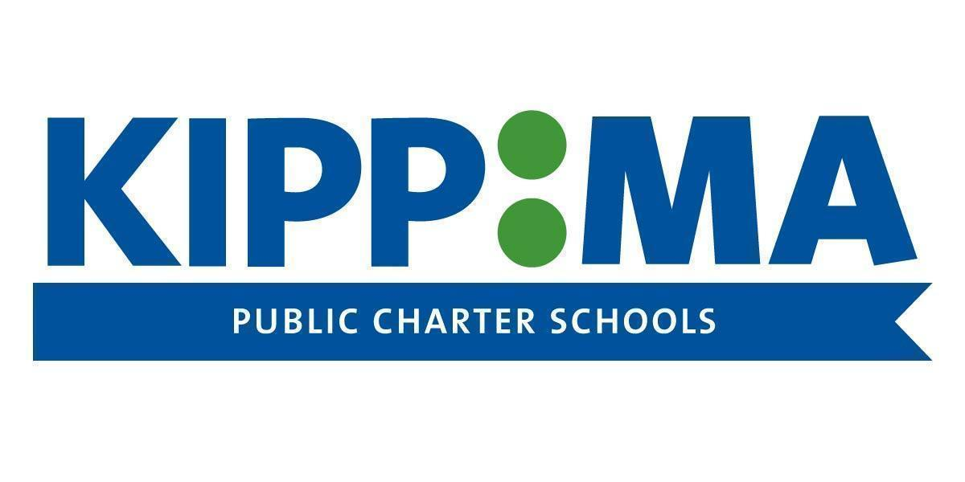

KIPP MA Teaching & Learning Committee Meeting
NOTICE and Agenda
Posted September 13, 2022

Notice:
The KIPP Academy Lynn Public Charter School and KIPP Academy Boston Public Charter School Teaching & Learning Committee will meet on September 16, 2022 at 1pm. The meeting will be held in person and via zoom.

ZOOM LINK: https://kippma-org.zoom.us/j/2279836270

For additional information, please contact Jesse Fetbroth at jfetbroth@kippma.org or 781-696-8402.

KIPP Academy Lynn Public Charter School and KIPP Academy Boston Public Charter School Teaching and Learning Committee

Date: September 16, 2022
Time: 1:00 - 2:00 pm
Location: 16 Woodhill Lane, Boxford, MA and zoom

Agenda Item | Materials
Introductions and Ice Breaker | n/a
Committee Composition and Recruitment Brainstorming | n/a
Review Committee Goals | n/a
Close out | n/a

